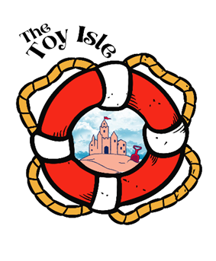
Be sure to head back to TheToyIsle.net for more free activites!
Have an A-Mazing time!

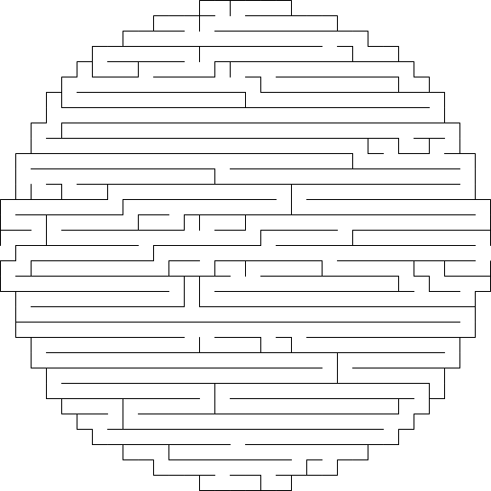
Start!
Finnish!

